With debugging, the 3 possibilities of error are:

1) The input given is wrong (the arguments passed to the function in the brackets or parenthesis). This is a precondition – i.e. something is wrong before the function is executed.

An example of python code of this error is shown in the screenshot below:

\*Providing more inputs than expected or the wrong type of input such as a character or undefined variable instead of an integer are examples of incorrect input.

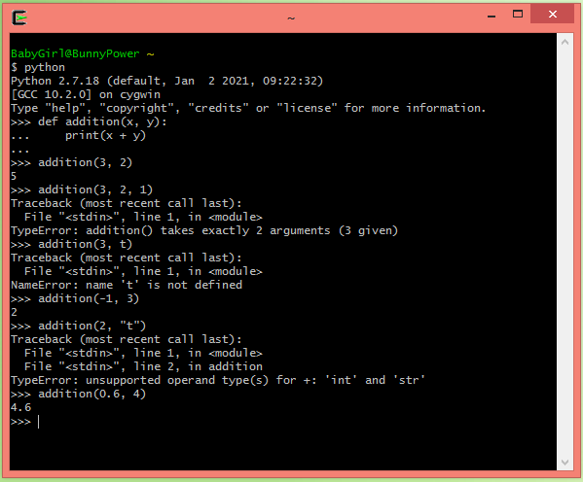

2) The function itself has an error (in the function’s code it is not doing what you expect it to). This is a postcondition – i.e. something is wrong after the function is executed.

An example of python code of this error is shown in the screenshot below:

\*Small mistakes like mixing up the order of things can cause issues. Below I created a function that is supposed to reverse the input given, but forgot to reverse it, then fixed it underneath.

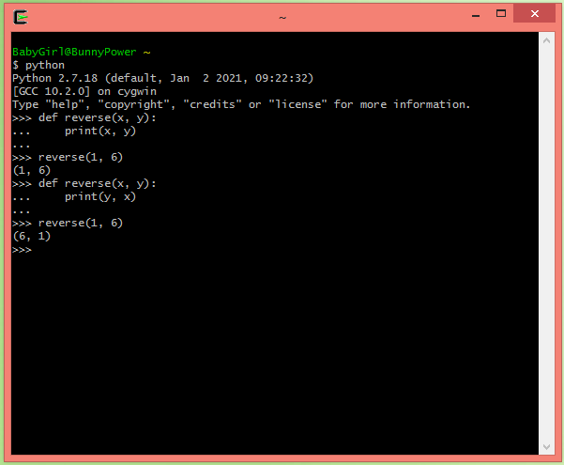

3) The value returned is erroneous (the output the function gives is not what is expected).

An example of python code of this error is shown in the screenshots below:

\*In the example below I kept returning the same function, calling it recursively without an exit clause until a depth error occurred. I should have added a loop break and returned the function with an altered input instead so it doesn’t give an error.

